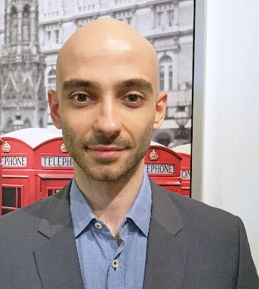 BIO - Filip Cornel Cristian

My name is Cornel Cristian Filip, I am 32 years old and I live in Bucharest which is the capital of beautiful Romania.  
  
I discovered my passion for programming about one year ago.  
I wanted to learn how to code for a couple of years. Finally, one year ago I decided it wat time to step up to the plate.  
  
At that time I was working at a corporation, WIPRO Ltd. , where I did technical support for MS Office 365 (Exchange Online, Outlook, SharePoint Online, Office Suite, Skype for Business).

I didn’t like it, but those 6 months helped me learn so much about myself and at the same time I realized the true power of technology and it’ s positive impact on the world.

So, after those 6 months, I decided to quit and started the learning process. In order to support myself financially, I rented a car and started working as an Uber driver. The fact that I was going to be able to make my own schedule in order to study and work at the same time helped me make this decision easier.

I started learning HTML5 and CSS3 on [w3schools](https://www.w3schools.com/), [MDN](https://developer.mozilla.org/en-US/), [stackoverflow](https://stackoverflow.com/), [codecademy](https://www.codecademy.com), [udemy](https://www.udemy.com/) and [teamtreehouse](https://teamtreehouse.com).

Through my LinkedIn account I got the chance to go to many interviews for Front-End positions and internships.

I went to a total of 8 interviews!

The 8th one was the lucky one, where I got the opportunity of an internship for a Full-Stack position at a start-up called Drift Data System. I’m very grateful I got the chance to work with extraordinary people from whom I acquired many skills.

The time I spent working at Drift Data System helped me absorb a lot about programming, working on a project and team work.

The first months I took JavaScript and SQL courses followed by a period in Angular 6+, the framework they were developing their app in.

My responsibilities were:

* Testing
* Bug fixing
* Contributing to the codebase

It was a great experience but unfortunately after 6 months we concluded our collaboration. So, when the contract ended, I decided it was time to find myself an environment in which I could grow as a programmer and a mentor to guide me through this journey.

Learning how to program was the best decision of my life!

I am currently continuing to study JavaScript, HTML5, CSS3 and Bootstrap.

In the future I would like to learn more about TypeScript, Node.js and Angular.

My GitHub profile :

<https://github.com/psyhedeliq>

My LinkedIn profile:  
<https://www.linkedin.com/in/cornelfilip/>

The courses I’m doing at present:

* [JavaScript Algorithms and Data Structures](https://www.udemy.com/js-algorithms-and-data-structures-masterclass/)
* [Advanced CSS and Sass: Flexbox, Grid, and Animations](https://www.udemy.com/advanced-css-and-sass/)
* [TypeScript Basics](https://ultimatecourses.com/courses/typescript)

The courses I finished:

* [Introduction To JavaScript](https://www.codecademy.com/pro/intensive/programming-with-javascript)
* [JavaScript Errors and Debugging](https://www.codecademy.com/learn/javascript-errors-debugging)
* [JavaScript Unit Testing](https://www.codecademy.com/learn/learn-javascript-unit-testing)
* [Learn SQL](https://www.codecademy.com/learn/learn-sql)
* [SQL: Table Transformation](https://www.codecademy.com/learn/sql-table-transformation)
* [SQL: Analyzing Business Metrics](https://www.codecademy.com/learn/sql-analyzing-business-metrics)
* [Web Design for Web Developers: Build Beautiful Websites](https://www.udemy.com/web-design-secrets/)
* [The Complete JavaScript Course: Build Real Projects](https://www.udemy.com/the-complete-javascript-course/)
* [Bootstrap 4](https://www.udemy.com/bootstrap-4-from-scratch-with-5-projects/)
* [Build Responsive Real World Websites with HTML5 and CSS3](https://www.udemy.com/design-and-develop-a-killer-website-with-html5-and-css3/)